**Chapter 1**

**Introduction**

* 1. **Problem Statement & Objective**

**Problem:** Businesses face challenges in ensuring the authenticity and value of their products and documents, as well as managing their product and credential data. Traditional methods can be time-consuming, costly, and prone to errors or data loss.

**Reasons:** Businesses face several challenges when managing their products and credentials. One of the main challenges is ensuring the authenticity and value of their assets. With the rise of counterfeit products and fake credentials, it can be difficult for businesses to prove the authenticity of their assets. Another challenge is managing product and credential data. Traditional methods of record-keeping can be time-consuming, costly, and prone to errors or data loss. These challenges can negatively impact a business’s reputation, customer trust, and revenue. By leveraging technology such as blockchain and NFTs, businesses can address these challenges and enhance the value and authenticity of their assets.

**Solution:** One solution to the challenges faced by businesses in managing their products and credentials is to leverage technology such as blockchain and NFTs. By creating NFTs of their products and credentials, businesses can provide a tamper-proof and easily verifiable digital asset that enhances the value and authenticity of their assets. This can help to build customer trust and loyalty, as well as provide a new revenue stream through the buying and selling of NFTs.

**Objective:** The objective of using technology such as blockchain and NFTs is to provide businesses with a secure and efficient way to manage their digital assets, while also offering a new and exciting way to engage with customers. By leveraging the power of blockchain technology and NFTs, businesses can offer a more secure, valuable, and engaging experience for their customers.

* 1. **Investigation & Analysis**

All users of this module can do the following functions using Drunken Bytes application.

**Business**

* Can create NFT using website and API
* Can view all NFT and Wallet Recharge Transactions.
* Can add Ether or Balance to Drunken Bytes Wallet.
* Can solve raised issues.
* Can create tickets.
* Can create templates.
* Can create API Keys.

**Sales**

* Can register business.
* Can solve tickets created by business.

**Support**

* Can repeat failed NFT Transactions.
* Can solve tickets created by business.

**Editor**

* Can write articles and blogs

**Admin**

* Can do all the tasks.
* Can manage all the users.

**System Analysis**

System analysis is the process of gathering and interpreting facts, diagnosing problems and using the information to recommend improvements on the system. System analysis is a problem solving activity that requires intensive communication between the system users and system developers. System analysis or study is an important phase of any system development process. The system is studied to the minutest detail and analyzed. The system analyst plays the role of an interrogator and dwells deep into the working of the present system. The system is viewed as a whole and the inputs to the system are identified. The outputs from the organization are traced through the various processing that the inputs phase through in the organization.

A detailed study of these processes must be made by various techniques like Interviews, Questionnaires etc. The data collected by these sources must be scrutinized to arrive to a conclusion. The conclusion is an understanding of how the system functions. The designer now functions as a problem solver and tries to sort out the difficulties that the enterprise faces. The solutions are given as a proposal. The proposal is presented to the user for an endorsement by the user. The proposal is reviewed on user request and suitable changes are made. This loop ends as soon as the user is satisfied with the proposal.

Analysis gathers the requirements for the system. This stage includes a detailed study of the business needs of the organization.

Design focuses on high level design like, what programs are needed and how are they going to interact, low-level design (how the individual programs are going to work), interface design (what are the interfaces going to look like) and data design (what data will be required).

During these phases, the software's overall structure is defined. Analysis and Design are very crucial in the whole development cycle. Any glitch in the design phase could be very expensive to solve in the later stage of the software development. The logical system of the product is developed in this phase.

* 1. **Introduction to Project**

The Product and Credentials NFT Platform for Businesses is a revolutionary system that allows businesses to create unique NFTs of their products and digital credentials. This platform provides an easy and secure way for businesses to manage their assets and increase their value. Through the use of blockchain technology, businesses can create a digital certificate or diploma as an NFT, ensuring that the document is tamper-proof and verifiable. Customers can then store their digital credentials in their personal digital wallet, allowing for easy access and sharing. In addition, businesses can create NFTs of their products, providing customers with a unique and valuable asset that can increase in value over time. These NFTs can be used for a variety of purposes, including proof of ownership, authenticity, and even as a collectible item. The Product and Credentials NFT Platform for Businesses is a powerful tool for businesses of all sizes. It provides a simple and efficient way to manage digital assets, while also offering a new and exciting way to engage with customers. With the ability to create NFTs of both products and credentials, businesses can enhance their brand and provide a more personalized experience for their customers. Overall, the Product and Credentials NFT Platform for Businesses represents a significant advancement in digital asset management. By leveraging the power of blockchain technology and NFTs, businesses can offer a more secure, valuable, and engaging experience for their customers.

* 1. **Proposed Solutions**

**Proposed System**

1. The proposed system is intranet-based system so passengers can also participate in viewing their belongings.
2. The platform provides detailed information about the business’s products and credentials, including their basic information and unique attributes.
3. It enhances the management of digital assets by allowing businesses to easily add, view, and update their NFTs, and generates various reports regarding their assets.

At a conceptual level, the platform represents different types of semantic objects, such as products and credentials. At the physical level, these objects are represented by unique NFTs on the blockchain. During a visit to the platform, a business may access and manage several of these objects together during a session.

The platform utilizes domain ontologies to provide a uniform architecture for modeling these objects. The general process for utilizing this integrated approach is composed of 3 main phases: preprocessing, pattern discovery, and online recommendation. Each of these phases takes into account the object properties and their relationships.

Overall, the proposed system aims to provide businesses with a secure and efficient way to manage their digital assets, while also offering a new and exciting way to engage with customers. By leveraging the power of blockchain technology and NFTs, businesses can offer a more secure, valuable, and engaging experience for their customers

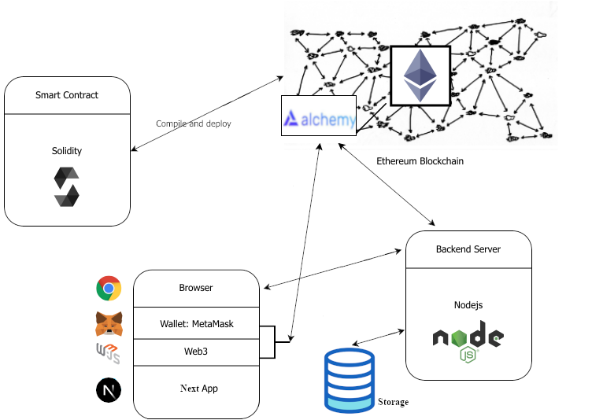

**Figure 1.1: Architecture Diagram of the Proposed System Methodology**

* 1. **Scope of the Project**

The scope of the Product and Credentials NFT Platform for Businesses is to provide a comprehensive and secure platform for businesses to create and manage NFTs of their physical and virtual products, as well as non-transferable documents such as certificates, diplomas, and degrees. This platform aims to enhance the authenticity and value of the products and documents by creating a unique and tamper-proof digital asset that can be easily verified by customers and other stakeholders.

The platform also aims to provide businesses with an efficient and cost-effective way of managing their product and credential data, eliminating the need for manual record-keeping and reducing the risk of data loss or theft. Additionally, the platform offers businesses the opportunity to reward their customers with a valuable and unique digital asset, which can help to build customer loyalty and trust.

Through the Product and Credentials NFT Platform for Businesses, businesses can also gain access to a wider market of buyers and investors who are interested in investing in unique and valuable digital assets. The platform provides a secure and transparent marketplace for buying and selling NFTs, offering businesses a new revenue stream and investment opportunity.

Overall, the scope of the Product and Credentials NFT Platform for Businesses is to revolutionize the way businesses manage and monetize their products and credentials, providing a secure and efficient platform for creating, managing, and trading unique and valuable digital assets.

**Chapter 2**

**System Requirements Specifications**

* 1. **Overall Description**

This section and its subsections contain the description of the project components such as interfaces, performance requirements, design constraints, assumptions and dependencies etc.

* + 1. **Product Perspective**

The application will be a web application.

* + - 1. **System Interfaces**

List each system interface and identify the functionality of the system (hardware and software both) to accomplish the system requirement and interface description to match the system.

* + - 1. **User Interfaces**

The application will have a user friendly and menu based interface. Following screens will be provided:

* **Business details:** The database consists of the name, logo, wallet address, commission charged, email id. These details provide valid login to user after getting registered.
* **Admin details:** The DB consists of the username, password, , email id. These details provide valid login to an admin.
  + - 1. **Hardware Interfaces**
* A network connection (internet / intranet) is required to make the web service accessible on other systems connected over the network.
* Other hardware interface specifications are as follows

**Minimum Requirements:**

|  |  |  |  |
| --- | --- | --- | --- |
| **Client Side** | | | |
|  | **Processor** | **RAM** | **Disk Space** |
| Google Chrome | Intel Pentium III or AMD -800 MHz | 1 GB | 100 MB |

**Table 2.1 Minimum Client Side Hardware Interface**

|  |  |  |  |
| --- | --- | --- | --- |
| **Server Side** | | | |
|  | **Processor** | **RAM** | **Disk Space** |
| Node.js | Intel Pentium III or AMD -800 MHz | 1 GB | 3.5 GB |
| MongoDB | Intel Pentium III or AMD -800 MHz | 512 MB | 500 MB  (Excluding Data  Size) |
| Goerli | Intel i3 Processor or AMD Ryzen 3 | 4 GB | 1 GB  (Excluding Data  Size) |

**Table 2.2 Minimum Server Side Hardware Interface**

**Recommended Requirements:**

|  |  |  |  |
| --- | --- | --- | --- |
| **Client Side** | | | |
|  | **Processor** | **RAM** | **Disk Space** |
| Google Chrome | Intel i3 Processor or AMD Ryzen 3 | 4 GB | 1 GB |

**Table 2.3 Recommended Client Side Hardware Interface**

|  |  |  |  |
| --- | --- | --- | --- |
| **Server Side** | | | |
|  | **Processor** | **RAM** | **Disk Space** |
| Node.js | Intel i3 Processor or AMD Ryzen 3 | 4 GB | 3.5 GB |
| MongoDB | Intel i3 Processor or AMD Ryzen 3 | 2 GB | 1 GB  (Excluding Data  Size) |
| Goerli | Intel i5 Processor or AMD Ryzen 5 | 16 GB | 1 GB  (Excluding Data  Size) |

**Table 2.4 Recommended Server Side Hardware Interface**

* + - 1. **Software Interfaces**
* Any Microsoft Windows 7 and higher (Windows 7 / 8 / 8.1 / 10) or equivalent Linux based operating system with minimum kernel support 3.X.
* Crystal Reports 8 for generation and viewing of reports
* We have chosen web application for its best support and user-friendliness.
* To implement the project we have chosen VS Code for its more interactive support.

**Minimum Requirements:**

|  |  |  |
| --- | --- | --- |
| **Software Tool** | **Version** | **Purpose of Use** |
| Operating System | Windows 7 and higher or Linux with kernel 3.x and higher | Installation and operational platform |
| Web Browser | Google Chrome, Brave and other higher compatible | Access to the web application |
| Web Server | Node Server | Running the web application over intranet |
| Database | MongoDB | Running and linking the database over internet/intranet to the online web application |

**Table 2.5 Minimum Software Interface**

**Recommended Requirements:**

|  |  |  |
| --- | --- | --- |
| **Software Tool** | **Version** | **Purpose of Use** |
| Operating System | Windows 8 and higher or Linux with kernel 3.x and higher | Installation and operational platform |
| Web Browser | Google Chrome, Brave and other higher compatible | Access to the web application |
| Web Server | Node Server | Running the web application over intranet |
| Database | MongoDB | Running and linking the database over internet/intranet to the online web application |

**Table 2.6 Recommended Software Interface**

* + - 1. **Communication Interfaces**
* Passenger on Internet will be using HTTP/HTTPS protocol.
* Client (Administrator) on Internet will be using HTTP/HTTPS protocol.
  + - 1. **Memory Constraints**
* At least 256 MB of RAM and 2 GB of space on hard disk will be required for running the application on client end.
* Similarly, a minimum of 2048 MB of RAM and 20 GB of space on hard disk will be required for running the application on server end.
  + - 1. **Operations**
* The DBA at the client side will be assumed responsible for manually deleting or archiving obsolete or non-required data from the database as per clients requirements.
* This will include database backup and recovery options also.
* The Node webserver will be hosted and maintained on a remote server addressed by a URL based address.
* The URL address may be intranet or internet based as per clients requirements.
* The 'SYSTEM RESET' function is provided that after confirmation from the administrator, will delete all the selective or complete data from the system.
  + - 1. **Project Functions**

The system will allow access only to authorized users with specific roles (Business, Admin etc.). Depending upon the user's role, he / she will be able to access only specific modules of the system.

A summary of the major functions that the software will perform:

1. A Login facility for enabling only authorized access to the system.
2. Business can create NFT for their Product and Credentials.
3. Business can manage and create their API Keys.
4. Support can help users with the problems they are facing with the platform
   * + 1. **User Characteristics**

* Educational Level: User should be at least graduate and comfortable with English.
* Experience: User should be well versed / informed about the structure of the program.
* Technical Expertise: User should be comfortable using general purpose applications on a computer.
  + - 1. **Constraints**
* Since the DBMS being used in this project is MongoDB, and the web server is Node Server, that are free open source tools, the server technologies are out of any guarantees, unless specifically purchased for enterprise environment.
* Due to limited features of DBMS being used, performance tuning features will not be applied to the queries and thus the system may become slow with the increase of data records being stored.
* Due to limited features of DBMS, database auditing will also not be provided.
* As the application runs over a network environment, well documented security policy is required to prevent and safeguard data as well as services over the network.
  + - 1. **Assumption & Dependencies**
* The number of domains being selected by the user does not change.
* The project Code will not change.
* The number of modules assigned to employee cannot be changed.

**Chapter 3**

**System Design Specifications**

* 1. **System Architecture**

System architecture presents the schematic view of the complete system along with its major components and their connectivity. The overall architecture of the proposed system will be as follows.

* 1. **Module Decomposition**

The proposed system can be decomposed into following major modules:

1. Smart Contract
2. User
3. API
4. Email
5. Database

**Module - 1:**

**SmartaContract:**  
A smart contract is a self-executing contract with the terms of the agreement between buyer and seller being directly written into code. In the context of a product and credentials NFT platform for businesses, a smart contract would serve as the underlying mechanism for creating, issuing, and managing NFTs.

When a business creates a new product or credential NFT, a smart contract is executed on the blockchain network to record the details of the NFT such as ownership, metadata, and other relevant information. The smart contract would also dictate the rules and conditions for the NFT, such as its transferability, expiration date, and other parameters as determined by the business.

Additionally, smart contracts can facilitate the validation and verification of credentials associated with an NFT, ensuring that only authorized parties can access certain information or privileges. This feature provides an added layer of security and trust for businesses and their clients.

Overall, smart contracts play a critical role in the functioning of a product and credentials NFT platform for businesses, allowing for the creation of unique and secure digital assets that can be seamlessly transferred and tracked on the blockchain network.

**Module - 2:**

**User:**

The User Module in the Product and Credentials NFT Platform for business enables users or businesses to access various features of the platform. They have the ability to create and customize their Product and Credentials NFT, as well as create and manage their API Keys and templates. Additionally, they can view and close raised issues and generate support tickets to receive assistance from the Drunken Bytes Team. The User Module also provides a comprehensive view of all transactions made on the platform, including both NFT transactions and wallet recharge transactions. Overall, the User Module offers a user-friendly and intuitive interface for businesses to efficiently manage their NFT products and credentials.

**Create NFT Page:**

The Create NFT page is a module of the Product and Credentials NFT Platform for business. This page allows users to create their own customizable NFTs for their products and credentials. Users can upload images, provide a description and set the desired price for their NFT. Additionally, they can specify the desired level of access control and define who can view or transfer their NFT. Once the user is satisfied with their NFT, they can save it and it will be available for purchase on the platform. The Create NFT page provides an easy-to-use interface for users to create unique and valuable NFTs that can be traded on the blockchain.

**NFT Transaction Page:**

The NFT Transaction Page is a section of the Product and Credentials NFT Platform where users can view all of their NFT transactions. This page provides a comprehensive list of all NFT transactions made by the user, including details such as the transaction amount, date and time, transaction status, and the NFT involved. The page also allows users to sort transactions by various criteria, such as date, transaction type, or NFT name, making it easy to find specific transactions. Users can also click on individual transactions to view more details, including the transaction ID, wallet address, and other relevant information. The NFT Transaction Page provides users with a clear overview of their NFT transaction history, helping them to track their assets and make informed decisions about future transactions.

**Wallet Recharge Transaction Page:**

The Wallet Recharge Transaction Page is a module in the Product and Credentials NFT Platform for businesses. It allows users to view all their wallet recharge transactions in one place. Users can see details such as the date and time of the recharge, the amount recharged, the payment method used, and the current balance in their wallet. This module provides businesses with an easy way to keep track of their financial transactions related to the NFT platform. Additionally, it helps users to identify any potential discrepancies or issues with their wallet balance. With this information readily available, businesses can better manage their finances and ensure the smooth operation of their NFT platform.

**Manage API Keys Page:**

The Manage API Keys page is an important module in the Drunken Bytes API platform that allows users to manage their API keys. Here, users can create new API keys, view existing keys, and delete old or unused keys. This module offers users a high degree of flexibility and control over their API usage, making it easier for them to manage multiple applications or services that may be consuming their API. The Manage API Keys page is also designed to be user-friendly, with simple navigation and clear instructions to help users perform their tasks quickly and easily.

**Templates Page:**

The Templates Page is a crucial module of the Product and Credentials NFT Platform for businesses. It allows users to create, manage and customize templates for their Product and Credentials NFT. This page provides an overview of all existing templates and allows users to edit or delete them. Users can also create new templates, specify the required fields and data types, and set the visibility and access permissions for each template. The Templates Page makes it easy for businesses to create consistent and customizable NFTs that meet their specific needs and branding requirements.

**Issues Page:**

The Issues page on the Product and Credentials NFT Platform is where a business can view and manage issues raised by their clients. This page allows the business to view details of each issue, such as the client’s name, the date the issue was raised, and the nature of the issue. From here, the business can also take action on each issue, such as responding to the client, escalating the issue to the appropriate team member, or resolving the issue. The Issues page serves as a central hub for managing client concerns and ensuring that they are addressed in a timely and effective manner.

**Tickets Page:**

The Tickets page is a section within the Product and Credentials NFT Platform for businesses where users can generate tickets to request assistance from the Drunken Bytes team. When a user encounters an issue or has a question about the platform, they can create a ticket and provide a description of the problem or inquiry. The Drunken Bytes team can then view and respond to the ticket, providing solutions or answering questions. Users can also view the status of their tickets and any past interactions with the Drunken Bytes team. This page helps to ensure that users have access to support when needed, promoting a positive user experience.

**Module - 3:**

**API:**

The API module in a software system acts as an interface between different software components, allowing them to communicate with each other. In the case of Drunken Bytes, the API module allows users or businesses to access the platform's services through a set of REST APIs. The APIs are designed to enable various functions such as creating and managing Product and Credential NFTs, managing API keys and templates, viewing and resolving raised issues, generating tickets for support, and managing transactions.

The API module is also responsible for handling user authentication and authorization, ensuring that only authorized users can access the platform's resources. It supports various authentication methods, including OAuth and API keys, which enable secure and controlled access to the platform's services. Additionally, the API module provides data validation and error handling capabilities to ensure that user requests are valid and any errors are properly handled.

The API module is a critical component of the Drunken Bytes platform, as it enables users and businesses to seamlessly integrate with the platform and leverage its services to create and manage their NFTs. It provides a reliable, secure, and scalable means of accessing the platform's services, making it easier for users to focus on their core business objectives.

**Module - 4:**

**Email:**

The email module in the Product and Credentials NFT Platform for businesses is responsible for handling email notifications and alerts to users and businesses. It enables the platform to send notifications about account registration, successful creation of NFTs, template creation, and other events that require user attention. Additionally, the email module allows users to reset their passwords by sending them a link via email to regain access to their accounts. The email module is designed to provide a seamless experience for users, ensuring that they stay informed and up-to-date with their account activities.

**Module - 5:**

**Database:**

The overall objective in the development of database technology has been to treat data as an organizational resource and as an integrated whole. DBMS allow data to be protected and organized separately from other resources.

Database is an integrated collection of data. The most significant form of data as seen by the programmers is data as stored on the direct access storage devices. This is the difference between logical and physical data.

Database files are the key source of information into the system. It is the process of designing database files, which are the key source of information to the system. The files should be properly designed and planned for collection, accumulation, editing and retrieving the required information.

The organization of data in database aims to achieve three major objectives:

* Data integration.
* Data integrity.
* Data independence.

The proposed system stores the information relevant for processing in the MySQL SERVER database. This database contains tables, where each table corresponds to one particular type of information. Each piece of information in table is called a field or column.

A table also contains records, which is a set of fields. All records in a table have the same set of fields with different information. There are primary key fields that uniquely identify a record in a table.

* 1. **High Level Design Diagrams**
     1. **Use – Case Diagrams**

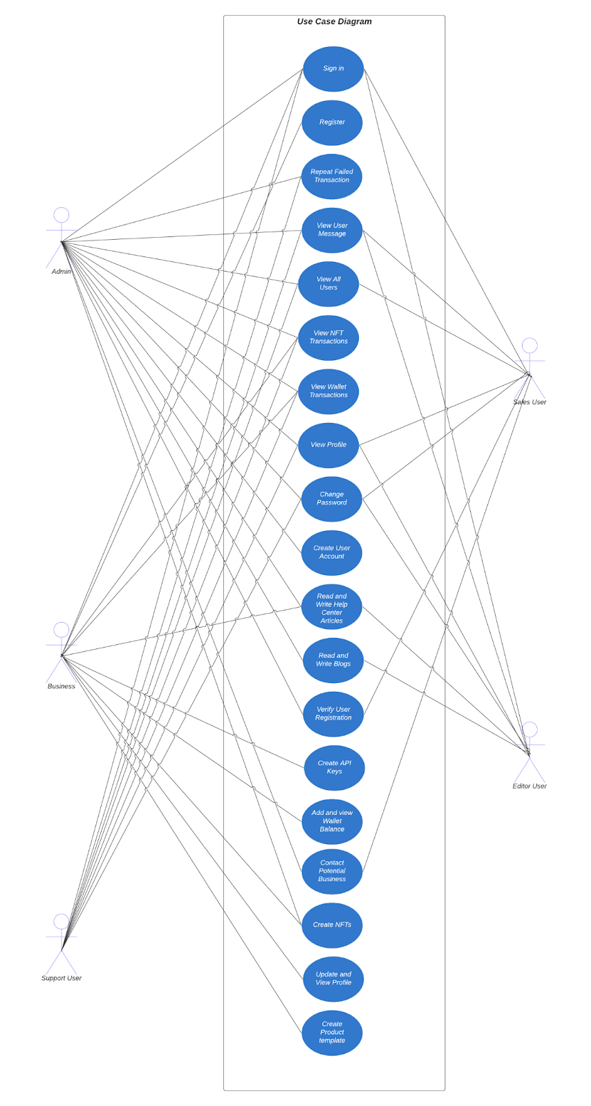

**Fig 3.1: Use - Case Diagram**

* + 1. **Activity Diagram**

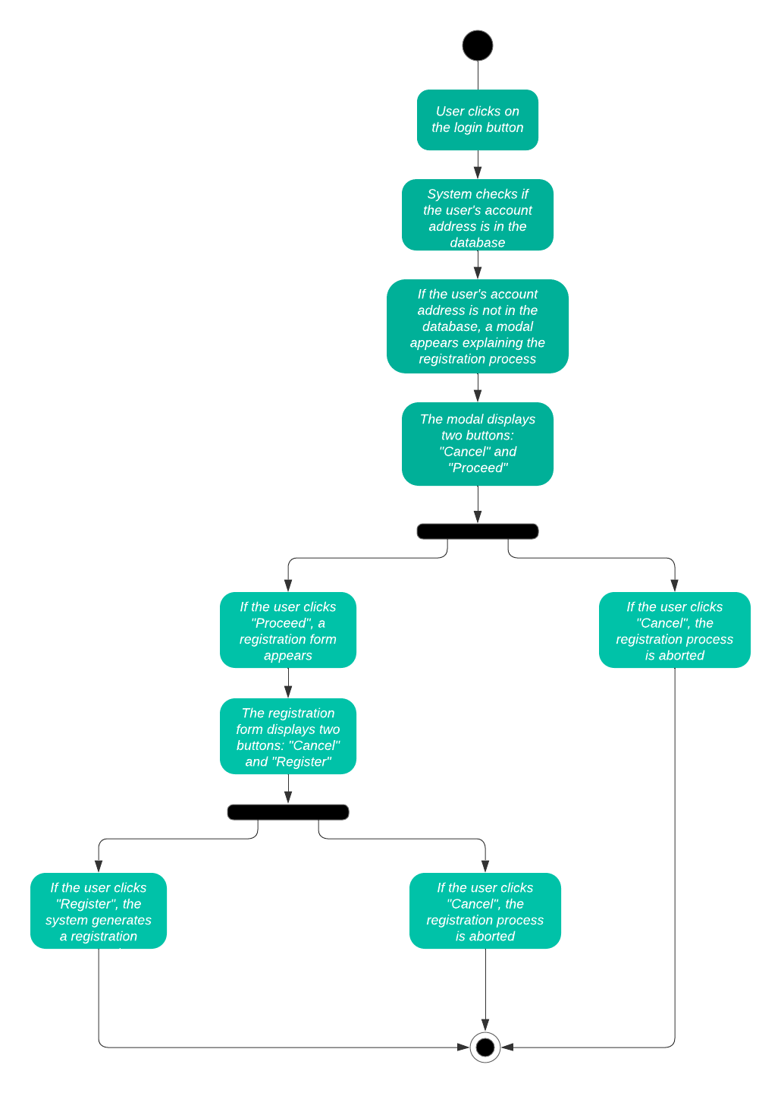

**Fig 3.2:** **Activity Diagram Representing User Registration**

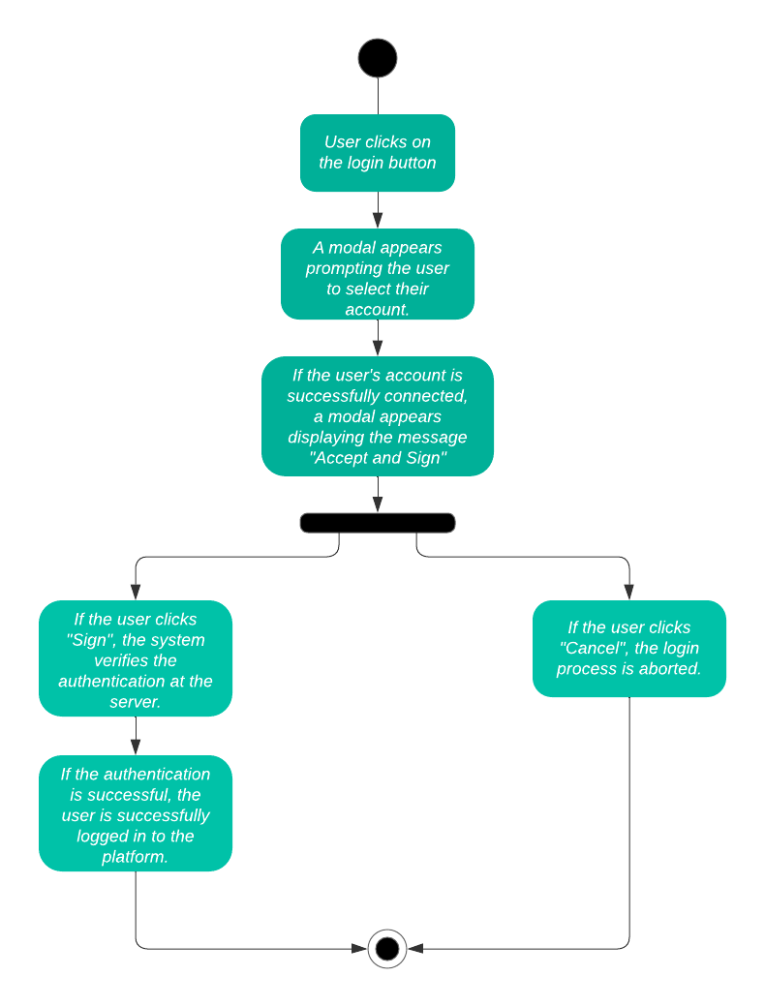

**Fig 3.3: Activity Diagram Representing User Login**

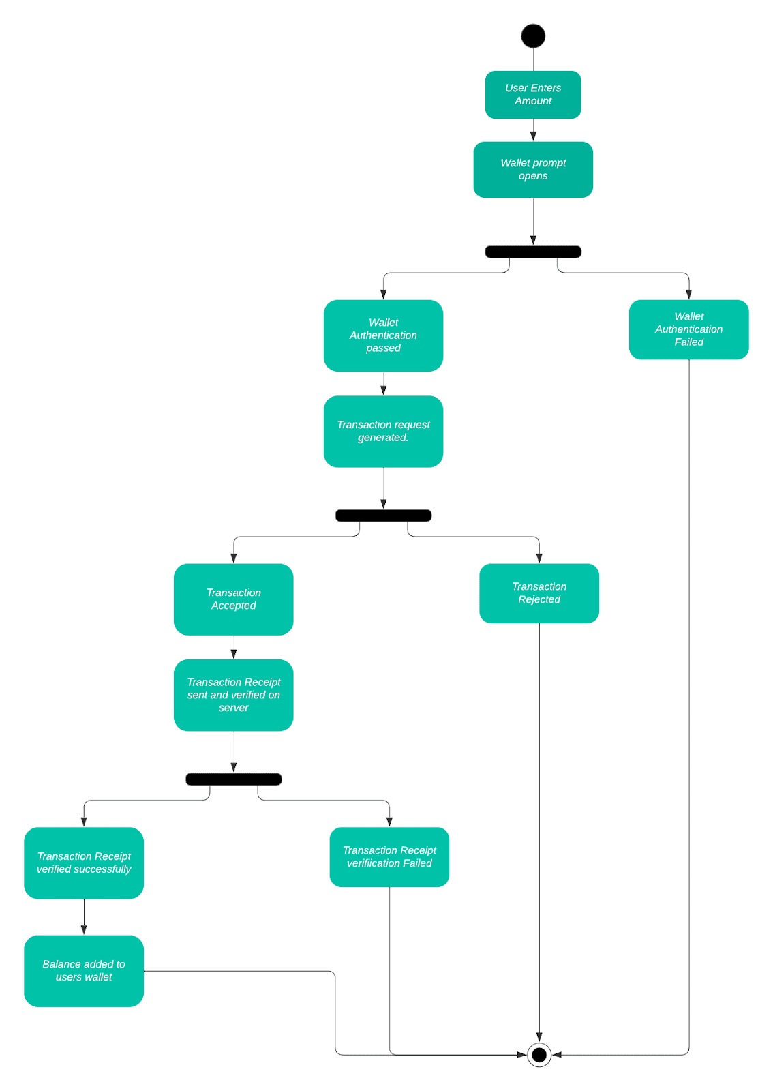

**Fig 3.4:  Activity Diagram Representing Add Wallet Balance**

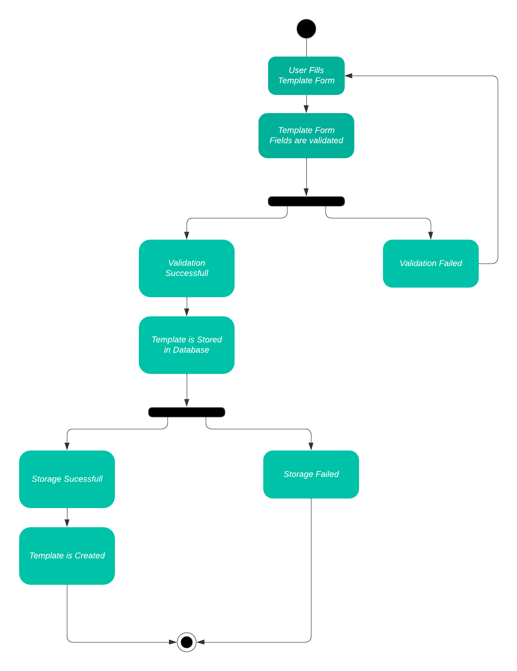

**Fig 3.5: Activity Diagram Representing Add Template**

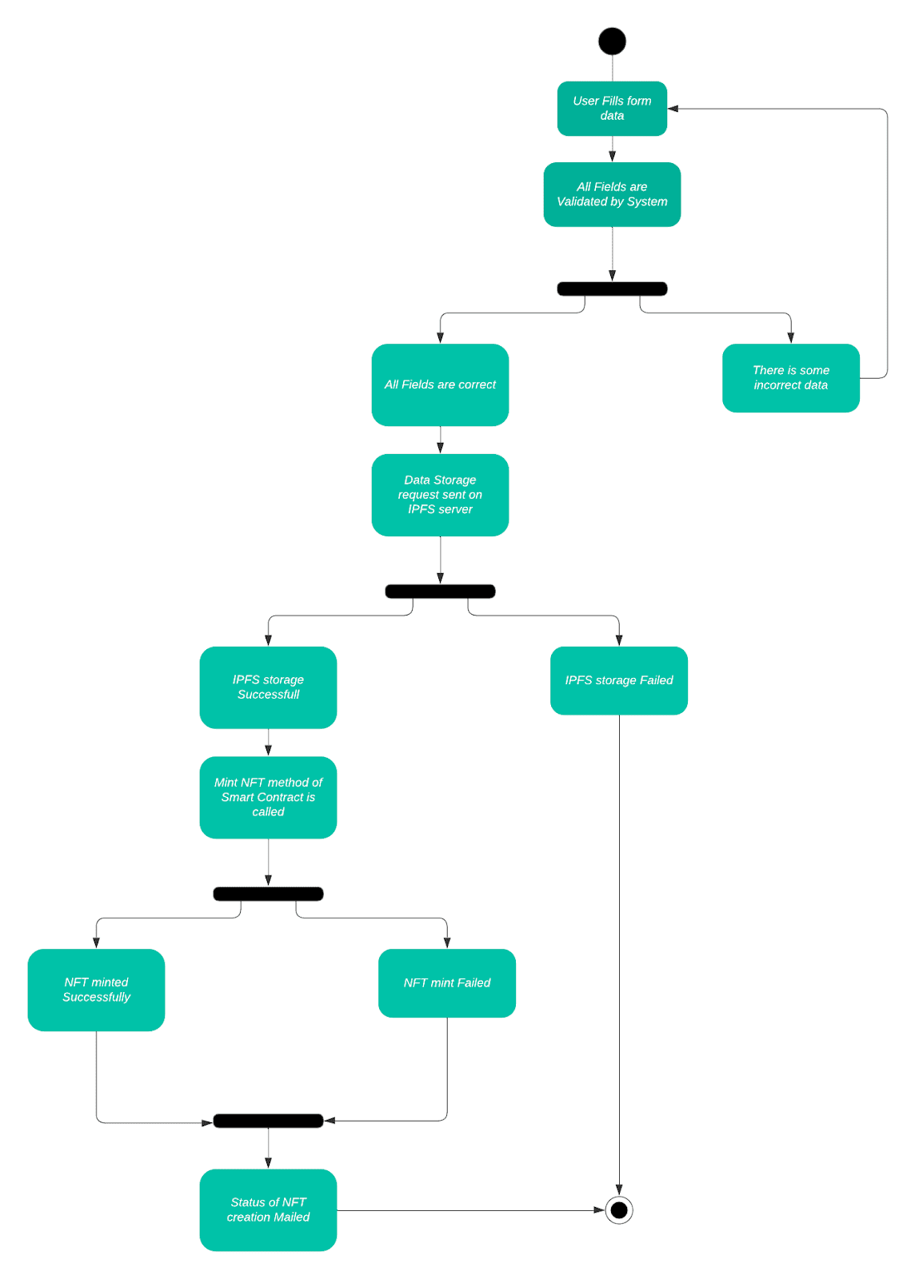

**Fig 3.6: Activity Diagram Representing Create NFT**

* + 1. **Data Flow Diagram**

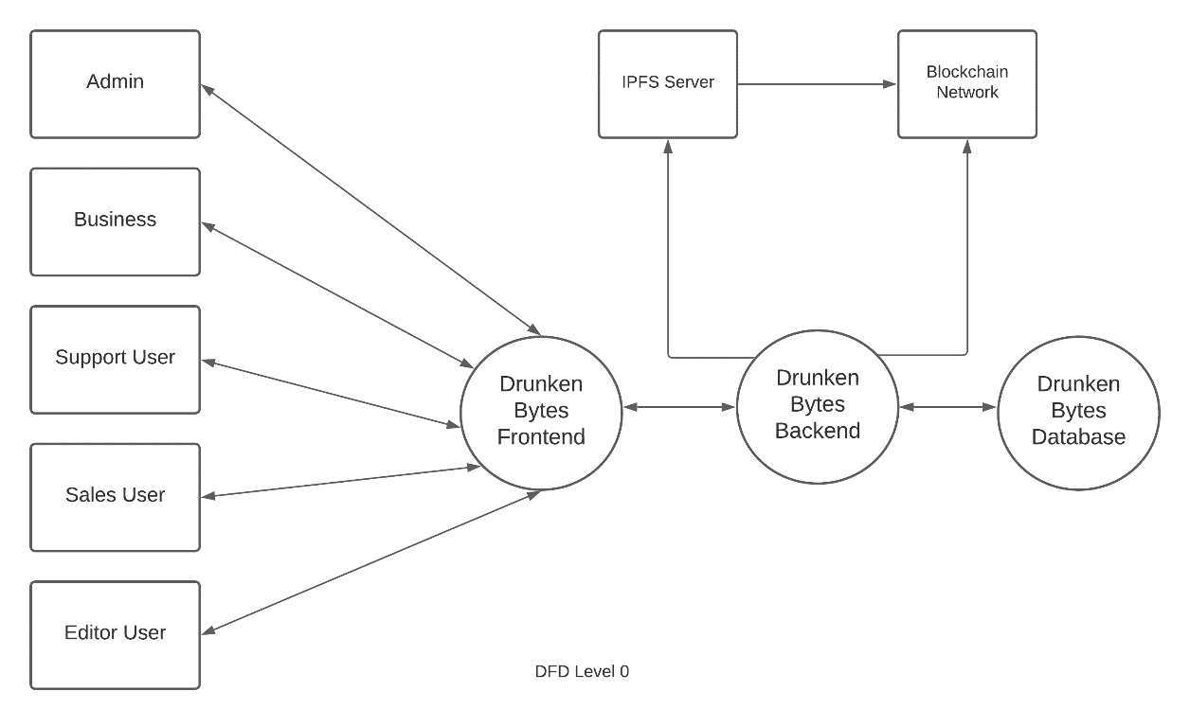

**Fig 3.7: Data Flow Diagram Level 0**

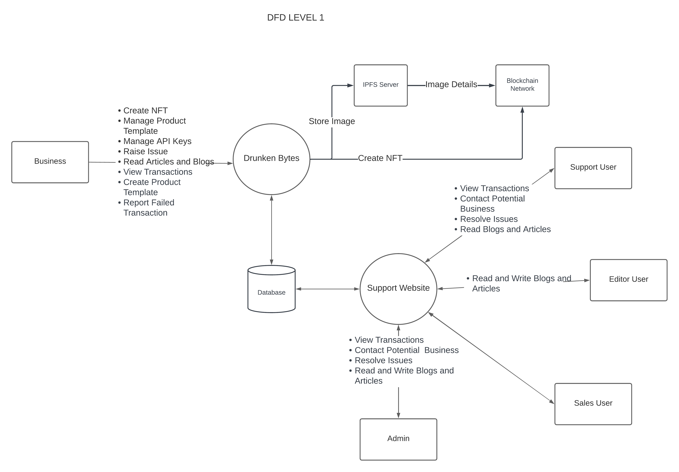

**Fig 3.8: Data Flow Diagram Level 1**

* + 1. **Class Diagram**

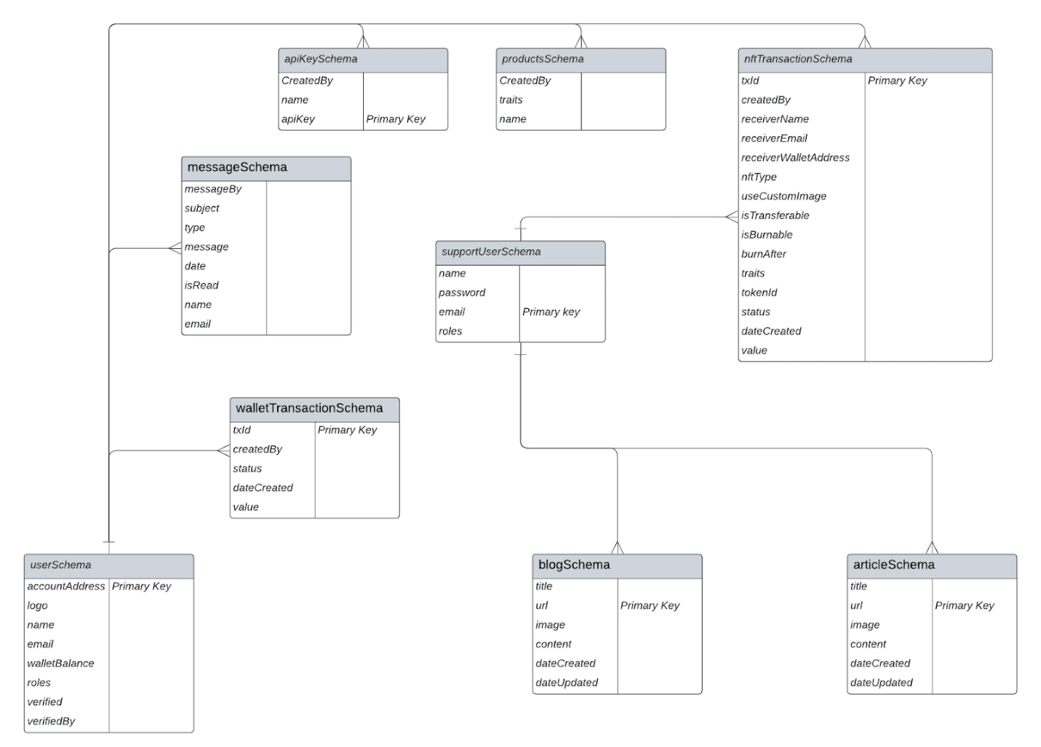

**Fig 3.9 : Class Diagram**

**Chapter 4**

**Methodology and Team**

* 1. **Introduction to Waterfall Model**

The Waterfall Model was first Process Model to be introduced. It is also referred to as a linear-sequential life cycle model. It is very simple to understand and use. In a waterfall model, each phase must be completed before the next phase can begin and there is no overlapping in the phases.

The waterfall Model illustrates the software development process in a linear sequential flow; hence it is also referred to as a linear-sequential life cycle model. This means that any phase in the development process begins only if the previous phase is complete. In Waterfall model, typically, the outcome of one phase acts as the input for the next phase sequentially.

Following is a diagrammatic representation of different phases of waterfall model.

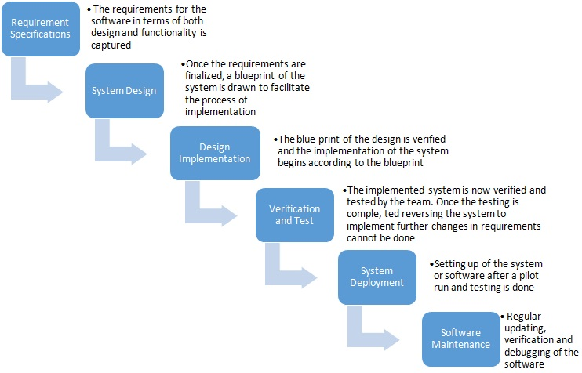

**Fig 4.1: Waterfall Model with Feedback**

The sequential phases in Waterfall model are:

* **Requirement Gathering and analysis:** All possible requirements of the system to be developed are captured in this phase and documented in a requirement specification doc.
* **System Design:** The requirement specifications from first phase are studied in this phase and system design is prepared. System Design helps in specifying hardware and system requirements and also helps in defining overall system architecture.
* **Implementation:** With inputs from system design, the system is first developed in small programs called units, which are integrated in the next phase. Each unit is developed and tested for its functionality which is referred to as Unit Testing.
* **Integration and Testing:** All the units developed in the implementation phase are integrated into a system after testing of each unit. Post integration the entire system is tested for any faults and failures.
* **Deployment of system:** Once the functional and non-functional testing is done, the product is deployed in the customer environment or released into the market.
* **Maintenance:** There are some issues which come up in the client environment. To fix those issues patches are released. Also to enhance the product some better versions are released. Maintenance is done to deliver these changes in the customer environment.

All these phases are cascaded to each other in which progress is seen as flowing steadily downwards through the phases. The next phase is started only after the defined set of goals are achieved for previous phase and it is signed off, so the name "Waterfall Model". Every software developed is different and requires a suitable SDLC approach to be followed based on the internal and external factors.

Some situations where the use of Waterfall model is most appropriate are:

* Requirements are very well documented, clear and fixed.
* Product definition is stable.
* Technology is understood and is not dynamic.
* There are no ambiguous requirements.
* Ample resources with required expertise are available to support the product.

**Waterfall Model Pros & Cons**

The advantage of waterfall development is that it allows for departmentalization and control. A schedule can be set with deadlines for each stage of development and a product can proceed through the development process model phases one by one.

The disadvantage of waterfall development is that it does not allow for much reflection or revision. Once an application is in the testing stage, it is very difficult to go back and change something that was not well-documented or thought upon in the concept stage.

* 1. **Team Members, Roles & Responsibilities**

|  |  |  |
| --- | --- | --- |
| **Team Members** | **Project Role** | **Responsibilities** |
| **Akshat Gadodia** | Team Member | Designing Smart Contract and Handling all the integration of smart contract and REST API creation. |
| **Akshita Sharma** | Project Manager | Frontend Designing, Rest API Creation and Database Handling |

**Table 4.1: Roles and Responsibilities**

**Chapter 5**

**Centering Testing System**

The designed system has been testing through following test parameters.

* 1. **Functionality Testing**

In testing the functionality of the web sites the following features were tested:

* **Links**

1. Internal Links:

All internal links of the website were checked by clicking each link individually and providing the appropriate input to reach the other links within.

1. External Links:

Till now no external links are provided in our website but for future enhancement we will provide the links to the candidate's actual profile available online and link up with the elections updates online etc.

1. Mail Links:

No mail links are provided in our website till this stage but this is also a future enhancement of our website to trigger mails to people for keeping them updated about the online registration dates, the polling dates and other details.

1. Broken Links:

Broken link are those links which so not divert the page to specified page or any page at all. By testing the links on our website there was no link found on clicking which we did not find any page.

* **Forms**

1. Field validation

Checks on dates have been applied. For e.g. The Date of birth should be less than the current date and after that we have checked the age to be greater than or equal to 18 years (the eligible age for casting vote). Checks have been applied on starting and ending dates, i.e. the starting dates of elections or registrations should always fall before their respective ending dates.

1. Error message for wrong input

Error messages have been displayed as and when we enter the wrong details (e.g. Dates), and when we do not enter any detail in the mandatory fields. For example: when we enter wrong password we get error message for acknowledging us that we have entered it wrong and when we do not enter the username and/or password we get the messages displaying the respective errors.

1. Optional and Mandatory fields

All the mandatory fields have been marked with a red asterisk (*) and apart from that there is a display of error messages when we do not enter the mandatory fields. For example: As the first name is a compulsory field in all our forms so when we do not enter that in our form and submit the form we get an error message asking for us to enter details in that particular field.

* **Database**

Testing is done on the database connectivity.

In the database testing we included following cases:

1. Entries in database through frontend and checked for the same in the tables.
2. Checked for the data types.
3. Checked for range of each type of data.
4. If entries made in one table are affecting other tables then we have checked those entries also.
5. We not just added details in the database by default but also did the same using the frontend.

**5.2 Performance Testing**

Performance testing can be applied to understand the website's scalability, or to benchmark the performance in the environment of third party products such as servers and middleware for potential purchase. This can only be done once it is put into use on the actual internet server and tested by the users.

Till now it is done using the null modem on two systems.

The system load includes:

1. What is the number of users per time?
2. Checking for peak loads and how system behaves.
3. Amount of data accessed by user.

This is done using only 2 systems for now so cannot be tested for load unless we deploy it on a real server machine.

* 1. **Usability Testing**

Usability testing is the process by which the human-computer interaction characteristics of a system are measured, and weaknesses are identified for correction.

1. Ease of learning
2. Navigation
3. Subjective user satisfaction
4. General appearance

As system is not put into the real time use so it's not yet tested for usability.

**Chapter 6**

**Test Execution Summary**

The Execution Test Summary Report is a crucial document that provides an overall view of the testing process from start to end. This report is typically generated at the end of the testing process and is given to the client for their understanding and review. The Test Summary Report contains important information about the testing process, including the test case IDs that were generated, the total number of resources consumed during testing, the number of test cases that passed and failed, and the overall status of the test cases.

The Test Summary Report contents are:

1. Test Case ID generated = PRO1, PR02, PRO3, PRO4, PRO5, PRO6, PRO7, PRO8
2. Total number of resources consumed = 2
3. Passed Test Cases = 8
4. Failed Test cases = 0
5. Status of Test Cases = Passed

This information is valuable for the client as it provides them with a clear understanding of the testing process and its outcomes. The client can use this information to assess the quality of the software being tested and to make informed decisions about its release.

In addition to the information provided in this summary report, there may be other details included in a Test Summary Report. These details may include information about the testing environment, the testing tools used, any issues or defects that were identified during testing, and any recommendations for future improvements.

The Test Summary Report is an important document that provides transparency and accountability in the testing process. It allows all stakeholders to have a clear understanding of the testing outcomes and to make informed decisions about the software being tested.

**Table 6.1: Test Case Summary**

**Chapter 7**

**Project Screen Shots**

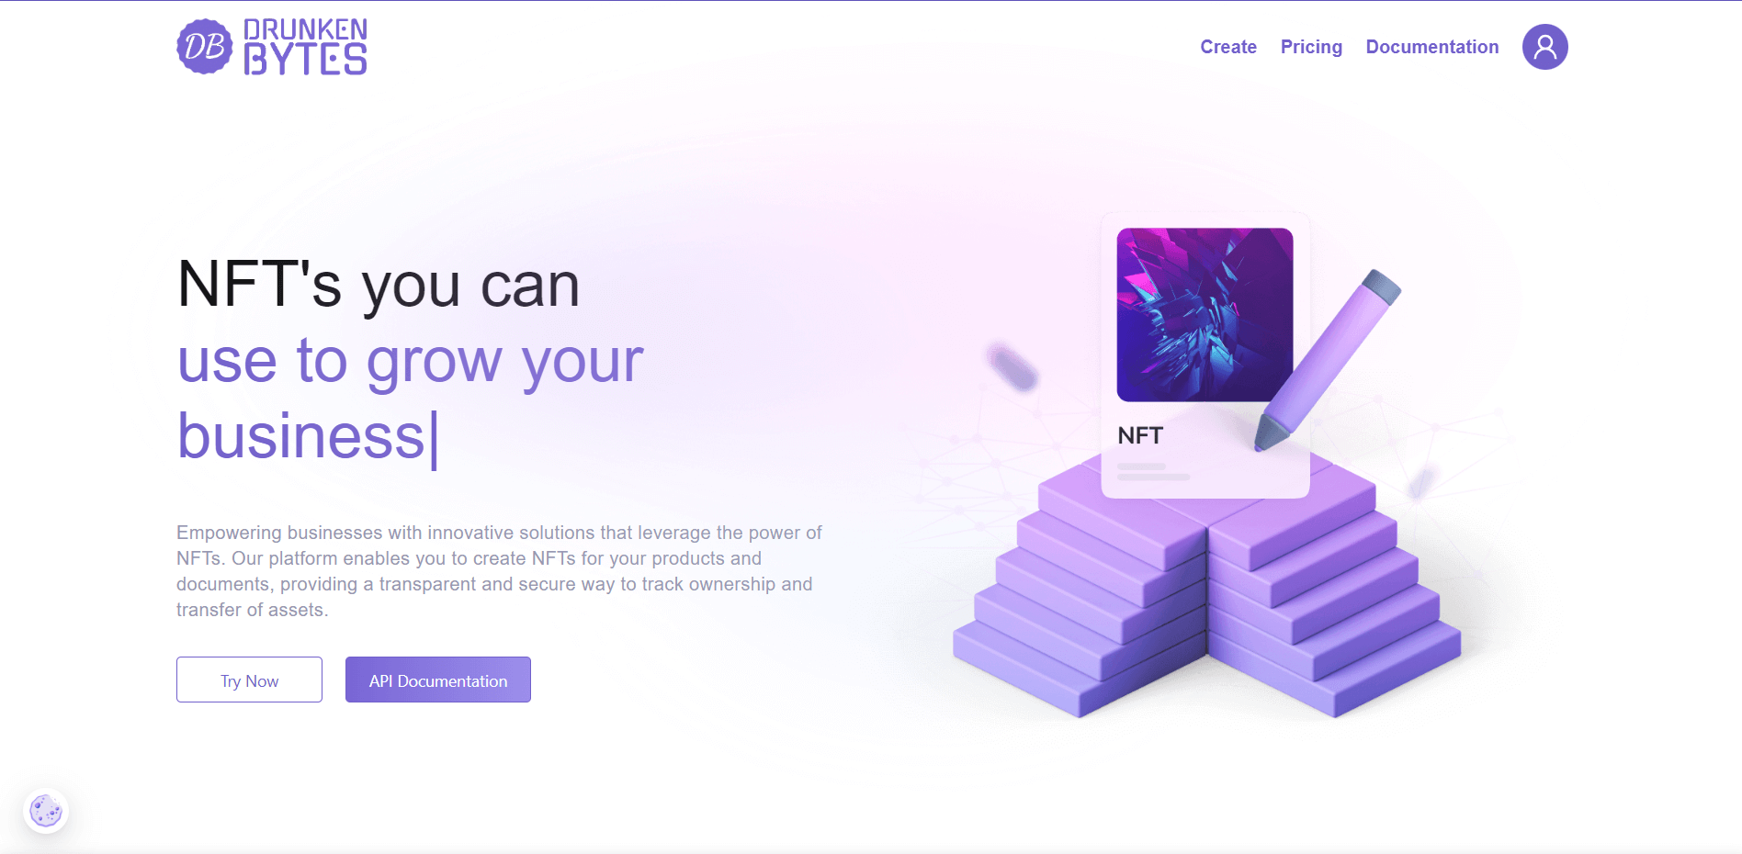

**Fig 7.1: Home Page**

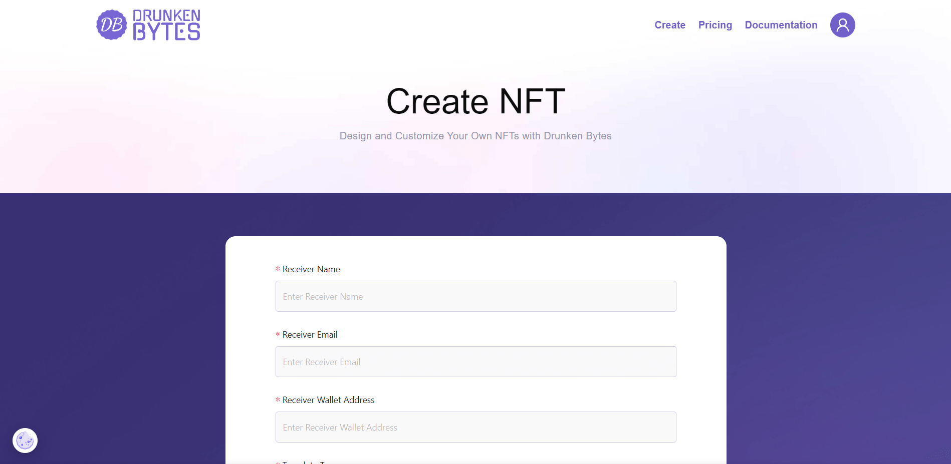

**Fig 7.2: Create NFT Page**

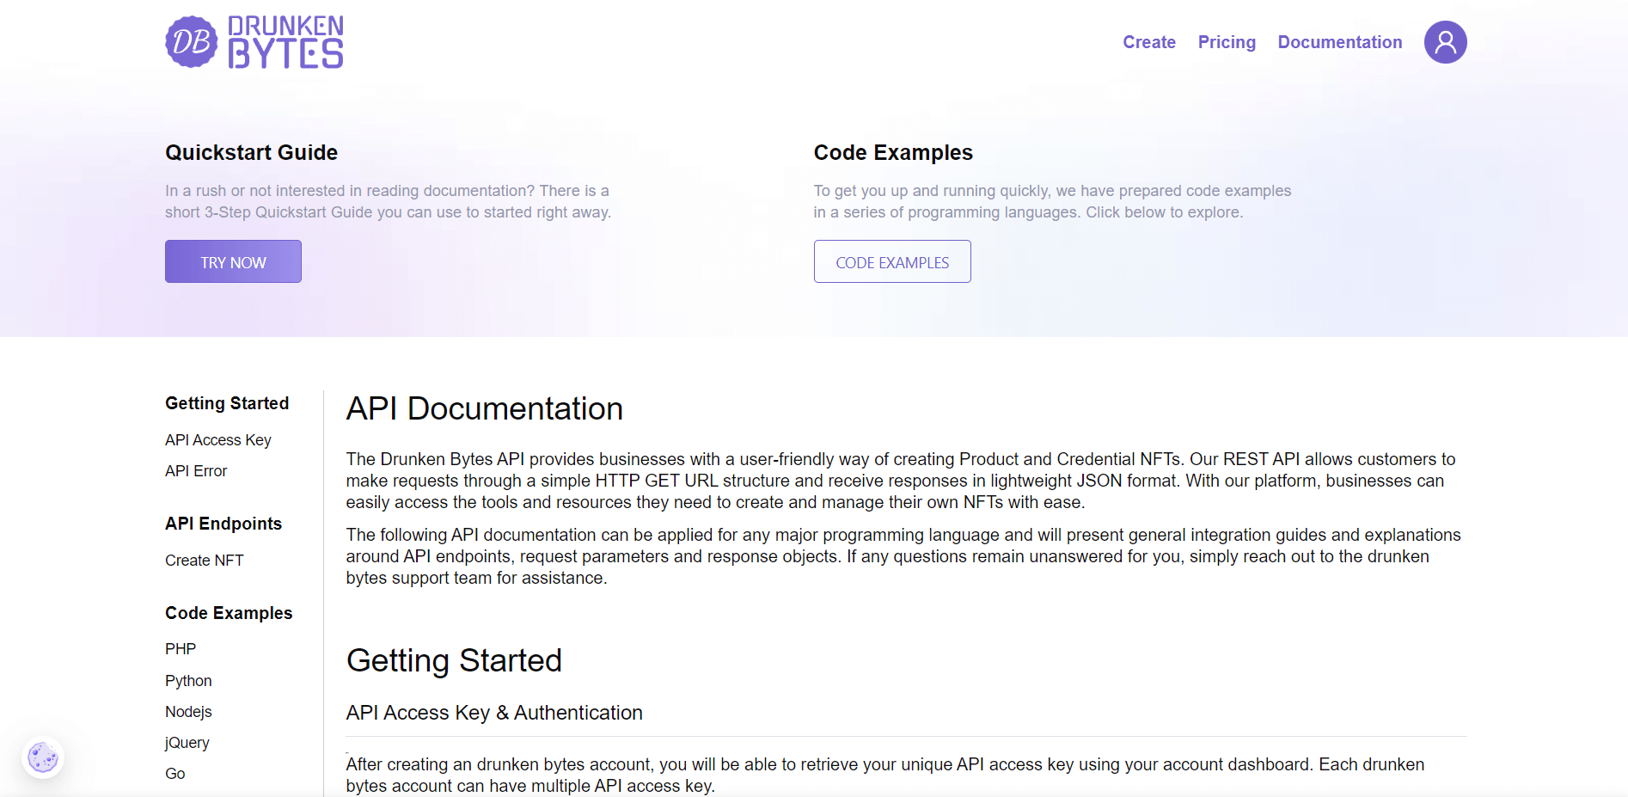

**Fig 7.3: Documentation Page**

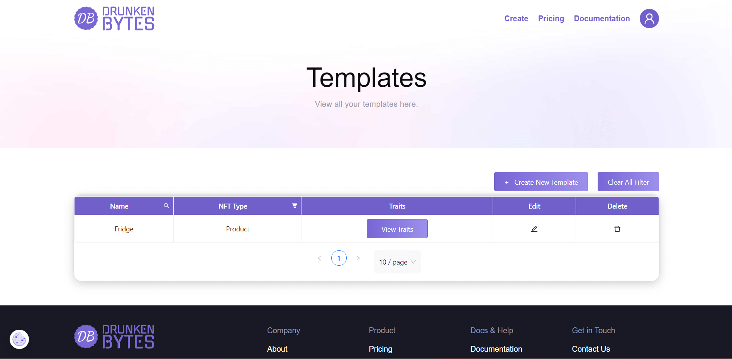

**Fig 7.4: Templates Page**

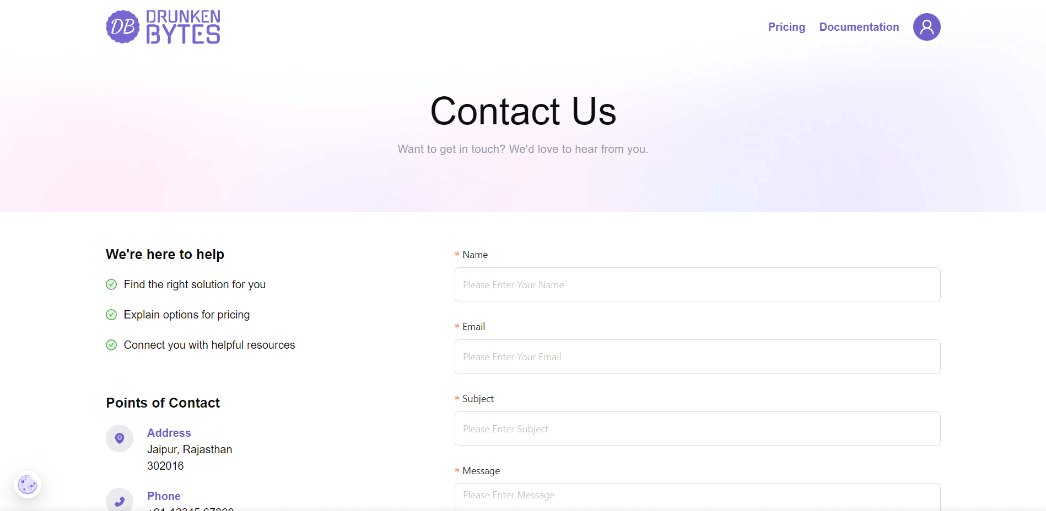

**Fig 7.5: Contact Us Page**

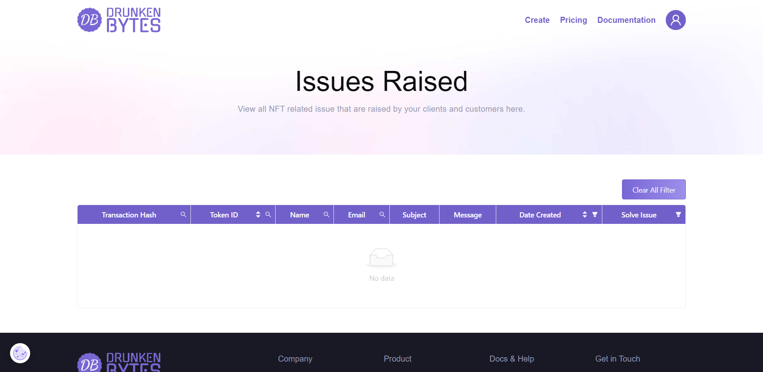

**Fig 7.6: Issues Page**

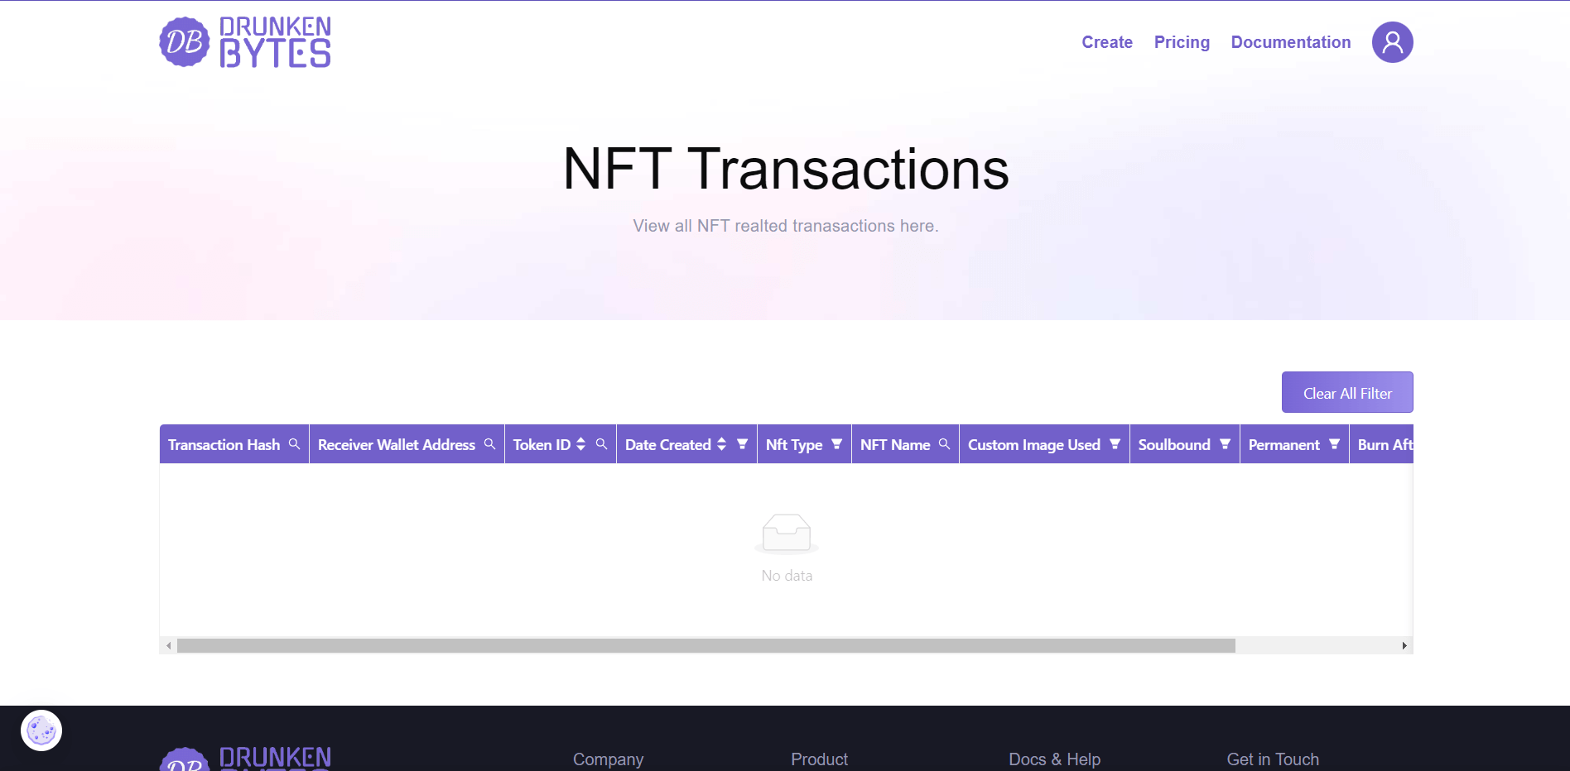

**Fig 7.7:** **NFT Transactions Page**

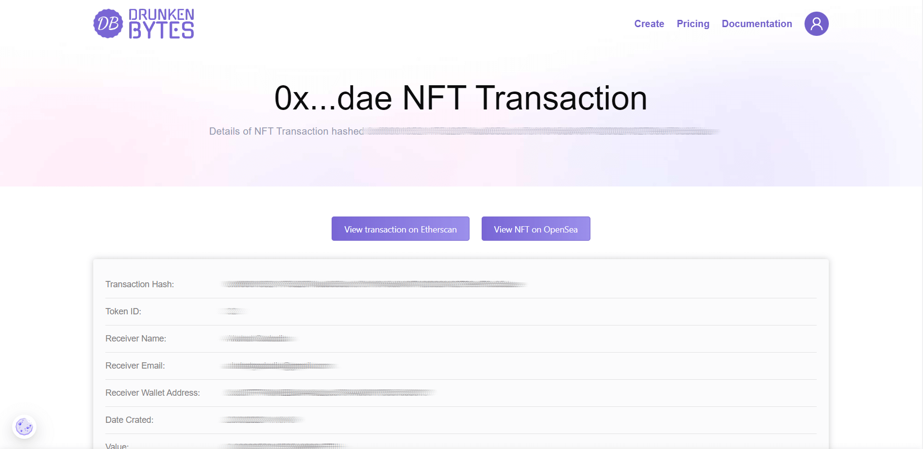

**Fig 7.8:** **NFT Transaction Page**

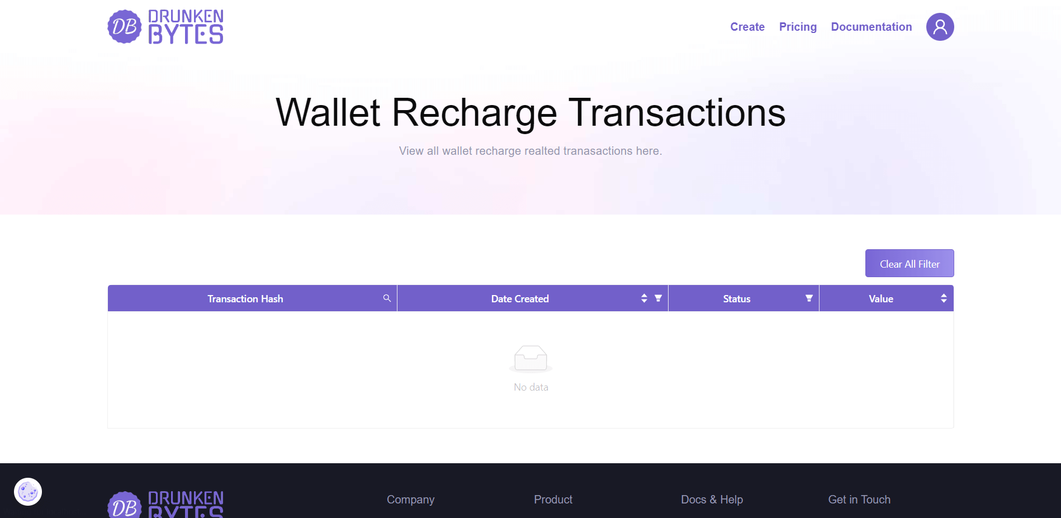

**Fig 7.9:** **Wallet Recharge Transactions Page**

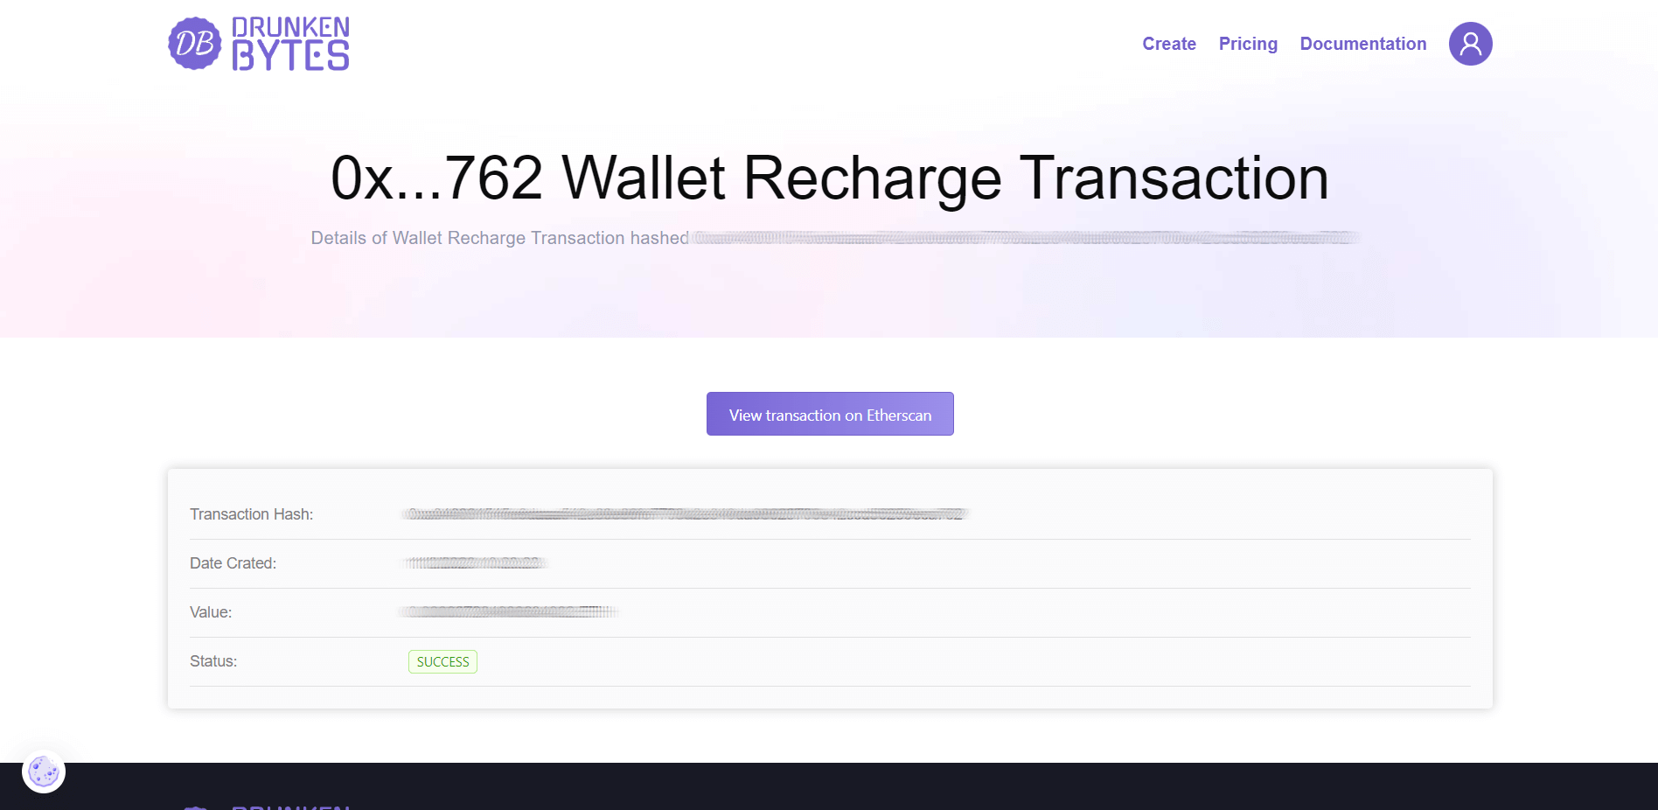

**Fig 7.10: Wallet Recharge Transaction Page**

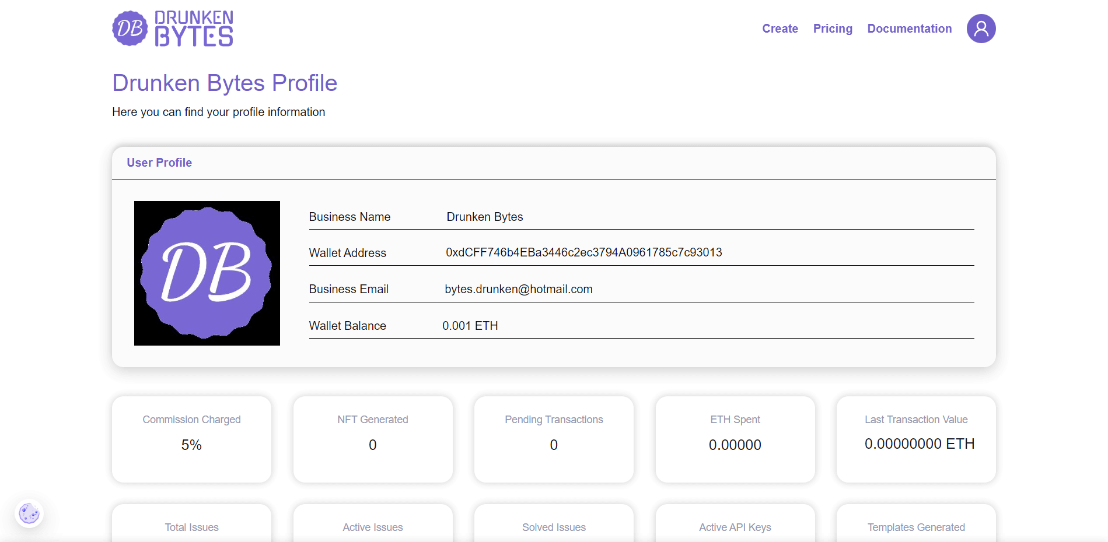

**Fig 7.11:** **User Profile Page**

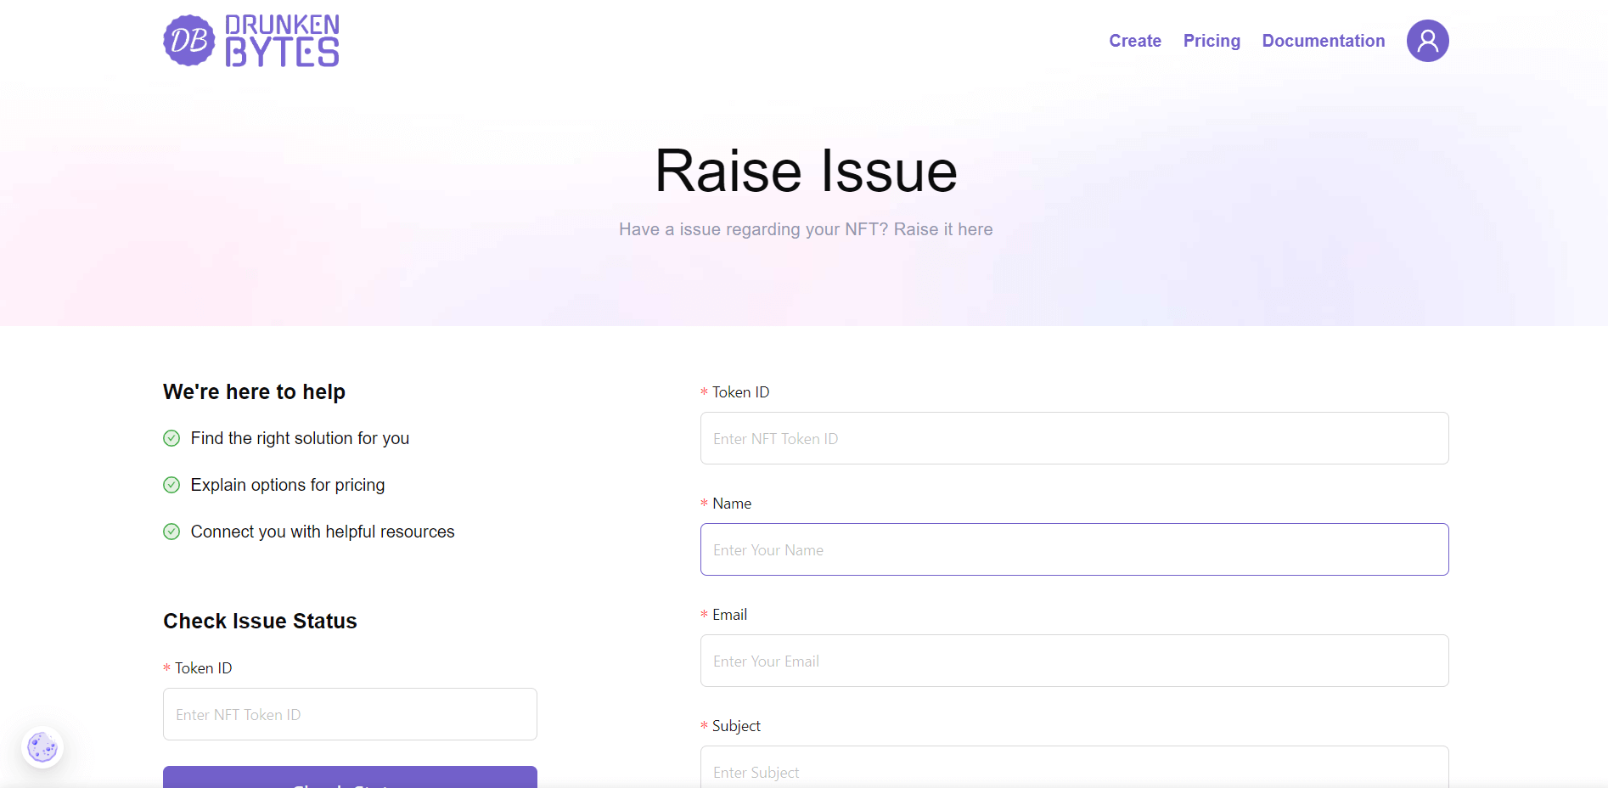

**Fig 7.12:** **Raise Issue Page**

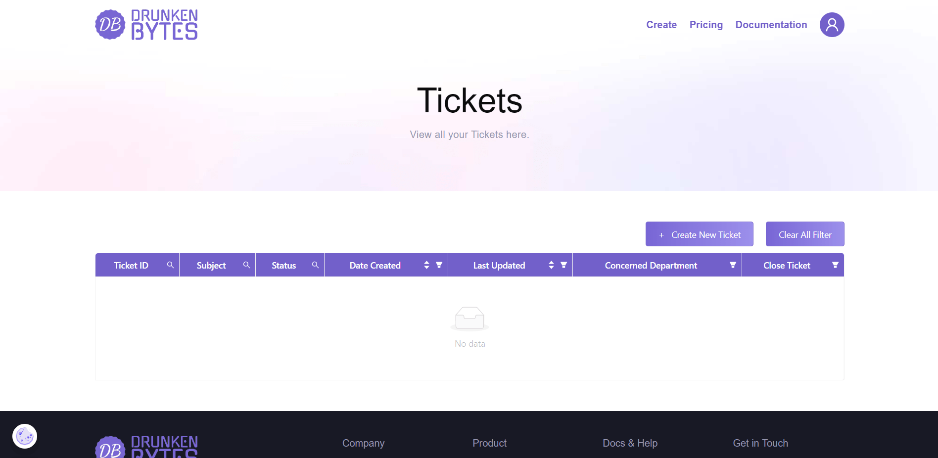

**Fig 7.13:** **Tickets Page**

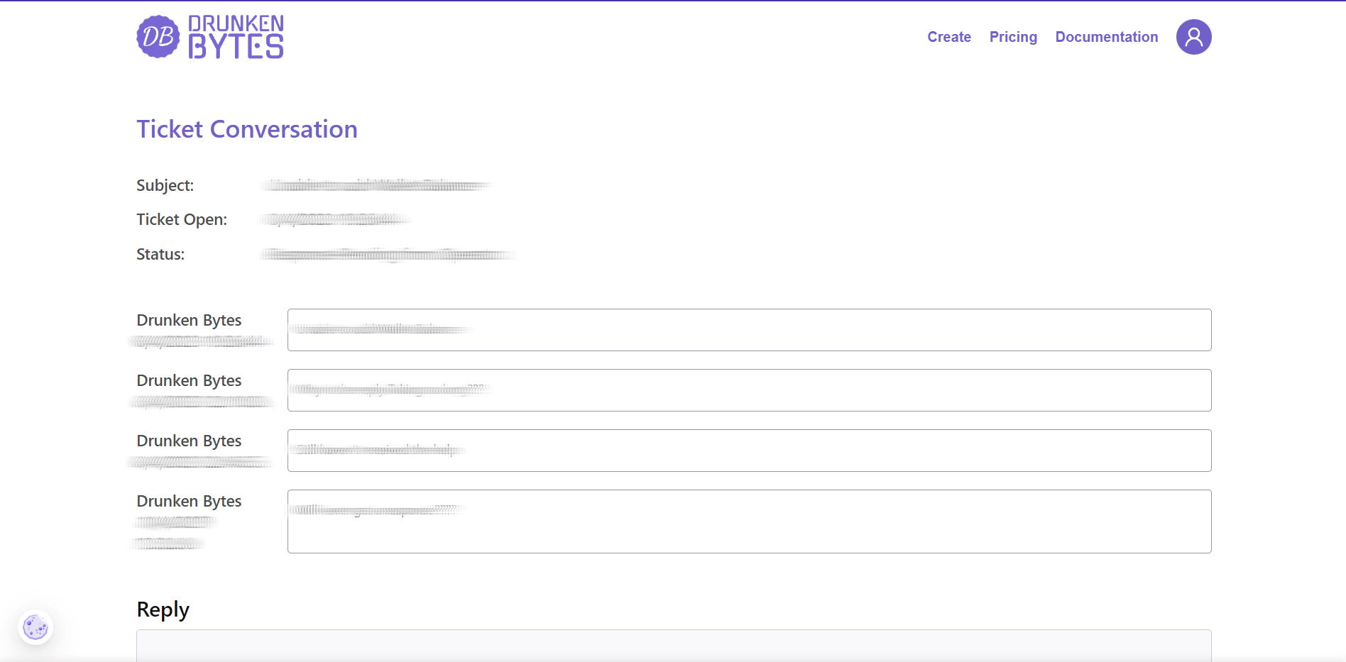

**Fig 7.14: Ticket Page**

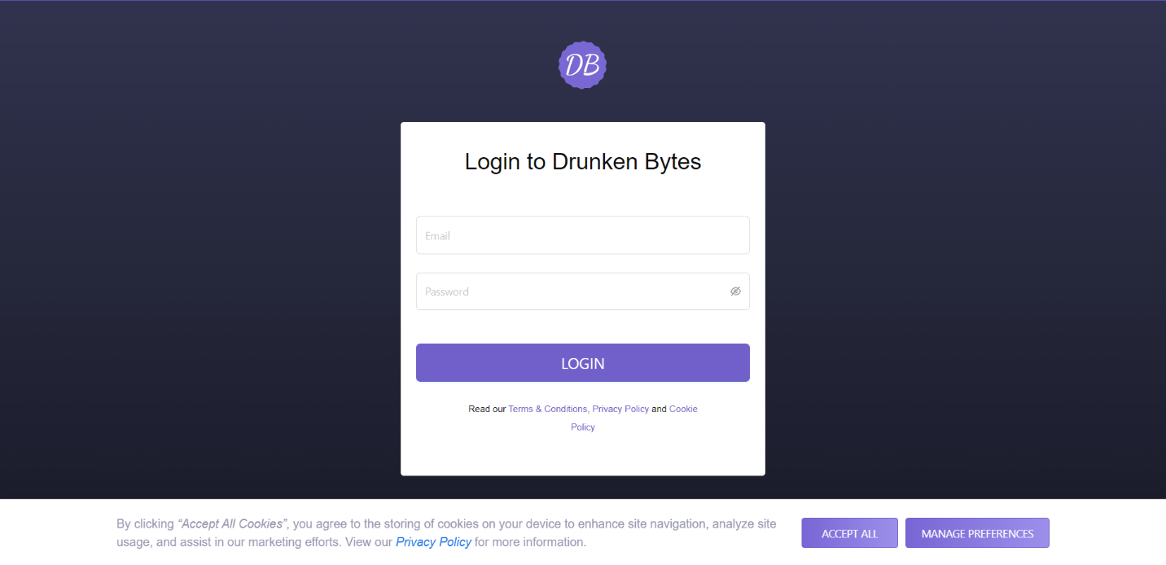

**Fig 7.15:** **Support Login Page**

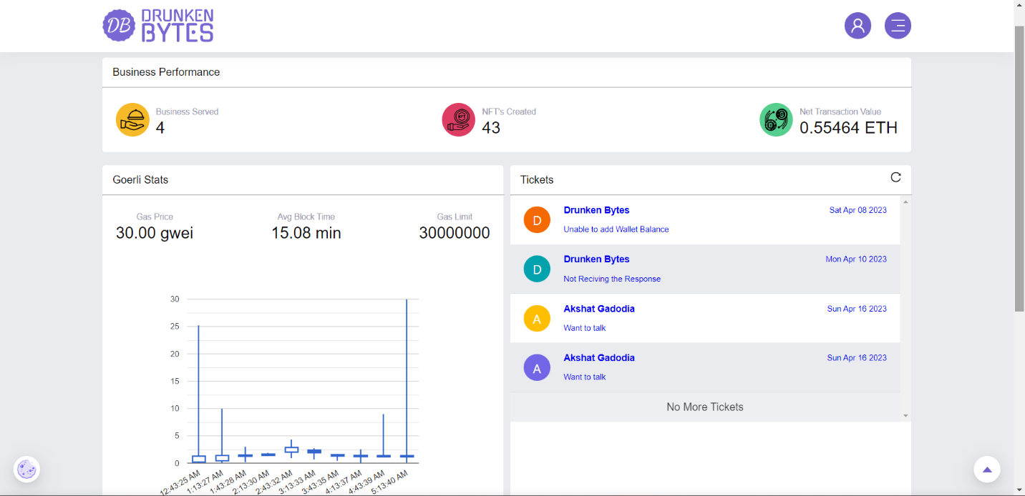

**Fig 7.16:** **Support Dashboard Page**

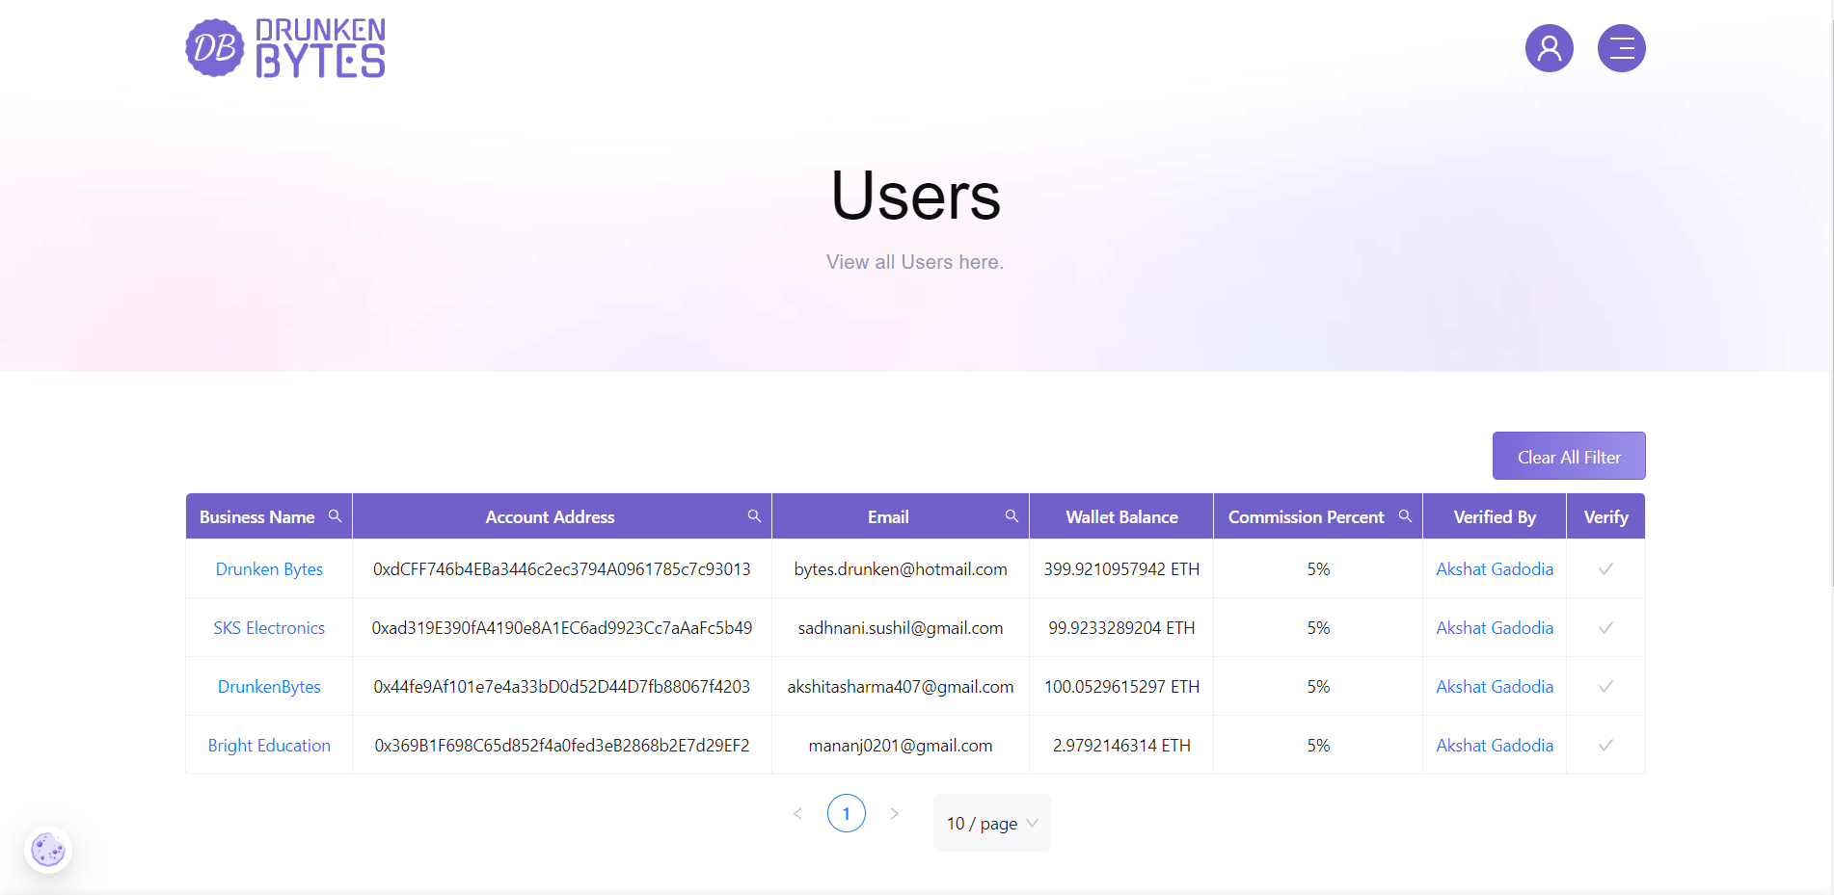

**Fig 7.17:** **Users Page**

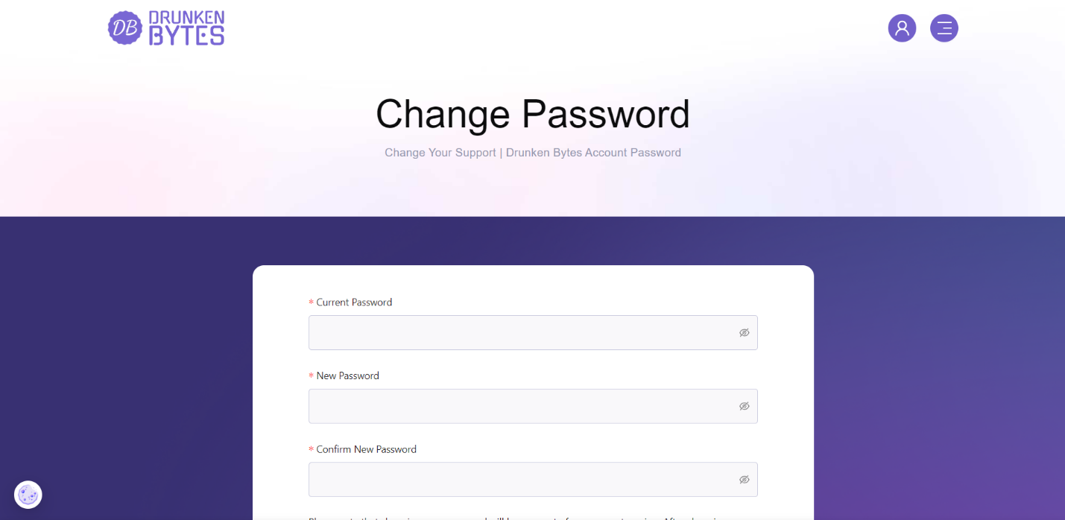

**Fig 7.18:** **Change Password Page**

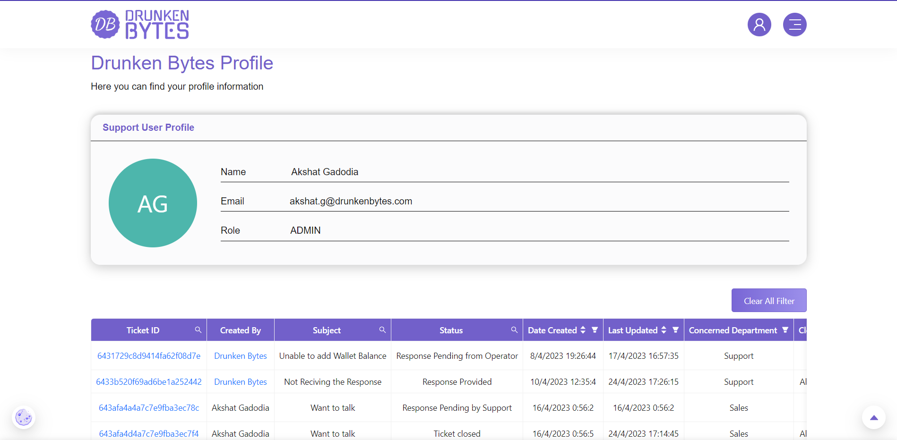

**Fig 7.19:** **Support Profile Page**

**Chapter 8**

**Project Summary and Conclusions**

**8.1 Conclusion**

Product and Credentials NFT Platform is a one-stop solution for businesses to create, manage, and track their products and credentials as NFTs. The platform is designed to provide businesses with an easy and secure way to manage their NFTs, API keys, and templates. The platform allows businesses to create custom NFTs for their products and credentials that can be traded on a blockchain-based marketplace.

The user or business is the main actor in the Product and Credentials NFT Platform. The platform provides businesses with a user-friendly interface to create, manage, and track their NFTs. Users can create and manage their API keys and templates, which they can use to customize their NFTs. The platform also provides users with the ability to view and close raised issues and generate tickets to get help from the Drunken Bytes team. Additionally, users can view all their transactions, including NFT transactions and wallet recharge transactions, through the platform.

The platform's smart contract for product and credentials NFTs is designed to ensure that NFTs are unique, authentic, and cannot be tampered with. This feature helps businesses to safeguard their products and credentials' authenticity, which is essential in today's market. The smart contract also allows businesses to transfer their NFTs easily to buyers or other parties, making transactions more transparent and secure.

The API module in the platform allows businesses to connect their systems to the platform easily. Businesses can create and manage API keys, which they can use to access the platform's services securely. This feature allows businesses to integrate the platform's services into their existing systems without any hassle.

The email module in the platform allows businesses to send and receive emails related to their NFTs, API keys, and templates. This feature helps businesses to communicate with their customers and the Drunken Bytes team easily.

In conclusion, the Product and Credentials NFT Platform provides businesses with a secure, efficient, and user-friendly way to manage their NFTs, API keys, and templates. The platform's smart contract ensures the authenticity and uniqueness of NFTs, while the API and email modules make it easy for businesses to integrate and communicate with the platform. The platform's features and design make it a valuable tool for businesses looking to manage their products and credentials as NFTs in today's market.

**Chapter 9**

**Future Scope**

Here are 10 possible future scopes of a Product and Credentials NFT Platform:

1. Increase in usage for secure and tamper-proof digital identification and verification of products and credentials.
2. Expansion of use cases beyond industries like supply chain management and educational institutions, to include sectors such as healthcare, finance, and government.
3. Integration with blockchain-based identity verification solutions for a more secure and decentralized approach.
4. Development of standards for interoperability between different NFT platforms, allowing for seamless transfer of product and credential ownership.
5. Introduction of smart contract-based functionalities, such as automatic renewal or revocation of licenses and certifications.
6. Utilization of NFTs to represent fractional ownership of products, enabling investors to own a small piece of high-value assets like real estate or artwork.
7. Introduction of gamification elements to incentivize user engagement, such as rewards for completing certain tasks or earning badges for achievements.
8. Development of mobile applications for easy and secure access to product and credential information on the go.
9. Introduction of social elements, such as the ability to share and display NFTs on social media or to connect with other users with similar interests or credentials.
10. Integration of AI and machine learning algorithms for predictive analytics, allowing for early identification of potential issues with products or credentials.

**References**

1. Object Oriented Modeling & Design with UML-Michael, James Rambaugh
2. Software Engineering, Seventh Edition, Ian Sommerville.
3. Node.js: https://nodejs.org/en/docs/
4. Express.js: https://expressjs.com/
5. Pinata: https://pinata.cloud/
6. Next.js: https://nextjs.org/docs/getting-started
7. Wikipedia - www.wikipedia.com
8. Database Management Systems - Navathe.
9. Goerli: <https://goerli.net/#about>
10. web3.js: <https://web3js.readthedocs.io/en/v1.3.4/>
11. ethers: <https://docs.ethers.io/v5/>
12. wagmi: <https://wagmi.io/whitepaper.pdf>

**Project Links**

* **GitHub Repository**

[**https://github.com/akshatgadodia/product-and-credentials-nft-platform-for-business**](https://github.com/akshatgadodia/product-and-credentials-nft-platform-for-business)

* **Deployed Websites**

[**https://drunkenbytes.vercel.app/**](https://drunkenbytes.vercel.app/)

[**https://supporrt-drunkenbytes.vercel.app/**](https://supporrt-drunkenbytes.vercel.app/)